Project Analysis Initial brainstorm Todd

Outside system: User, (Database)

Input Data: Username, Password, Gender, Weight, Height, Age, Activity Level, Target Weight; these are input by the user during creation and updating.

Output data: Displayed to the user: Gender, Weight, Height, Age, Activity Lever, Target Weight, calories needed to meet target, progress chart.

Data Processing: Calculate daily calories to meet target. Use historic data to make progress chart. Update user information (including goal). Log in /authenticate user. Delete user.

Context Diagram:

Username, Password, Gender, Weight, Height, Age,

Activity Level, Target Weight

Gender, Weight, Height, Age, Activity Lever, Target Weight,

calories needed to meet target

Subsystem diagram

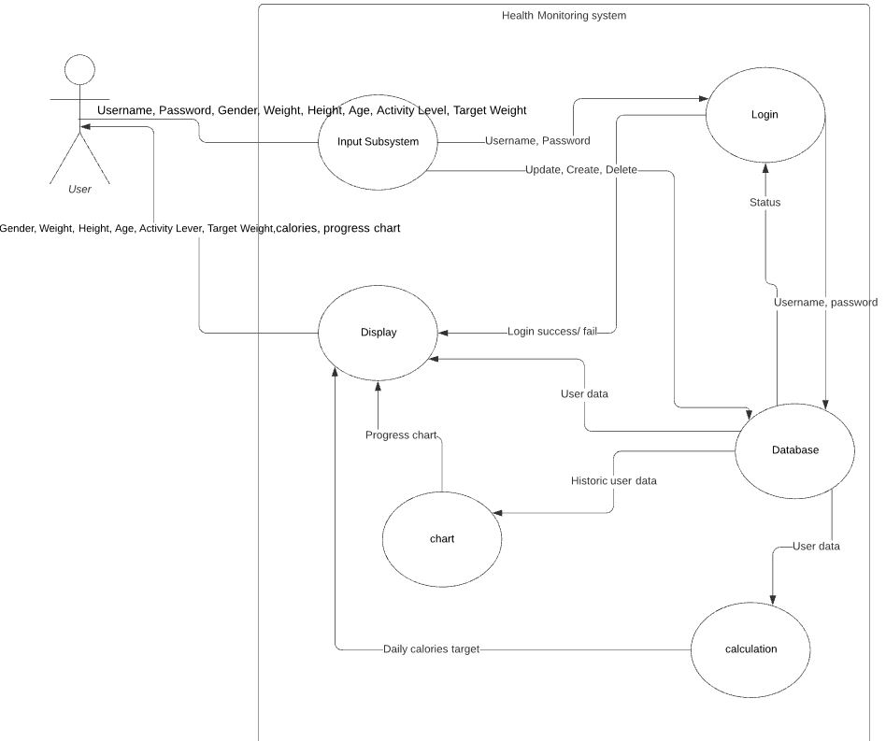

Description of subsystems:

1. Input subsystem receives the following input form the user: Username, Password, Gender, Weight, Height, Age, Activity Level, Target Weight
2. The login subsystem takes the Username and password and queries the database to authenticate the user and displays a message if successful or unsuccessful.
3. The Calculation subsystem takes the user data from the database and calculates the daily caloric target and updates the display.
4. The chart subsystem takes historic data from the database and updates the display with a progress chart
5. The display subsystem shows the current user data retrieved from the database, the progress chart, daily caloric calculation, login message to the user.
6. The database subsystem hosts data and respond to requests from other systems.

Table mapping requirements to subsystems:

|  |  |
| --- | --- |
| Requirement # | Description |
| **Functional Requirements** | |
| 1 | Display |
| 2 | Display |
| 3 | Display |
| 4 | Display, Database |
| 5 | Input, Database |
| **Unique User Account Requirements** | |
| 6 | Database |
| 7 | Input |
| 8 | Input |
| 9 | Input |
| 10 | Input, Display, Database, Login |
| 11 | Input, Display, Database, Login |
| 12 | Input, Display, Database, Login |
| 13 | Display, Database, Login |
| 14 | Input, Database, |
| 15 | Input, Database, Login |
| **GOAL Data Requirements** | |
| 16 | Database |
| 17 | Display, Database |
| 18 | Display, Chart, Database, Calculation |
| 19 | Display, Database |

Possible enhancements: Allow the user to export data, Weekly reminders, 2FA.

Possible risks/ mitigations.

Risk: loss of data. Mitigation: Backups

Risk: Account Hacked. Mitigation: Allow password reset

Risk: Exposing data. Mitigation: Keep user login separate from user data.